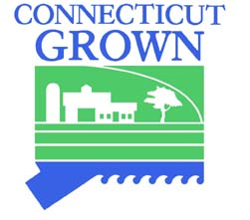
GLASTONBURY FARMERS MARKET
COALITION, INC.

2023 MARKET SPONSORSHIP OPPORTUNITIES

The Glastonbury Farmers Market connects the Glastonbury community to local farmers, makers of baked goods and artisanal products and provides an opportunity to support local businesses, musicians, and artists. Please support our efforts!

- 300 Level – SAGE
  - Name and logo on GFM website
  - Name and logo on GFM Facebook page
  - Name and logo displayed each Market Day
  - Booth available for four Market Days

- $500 Level – ROSEMARY
  - Name and logo on GFM website
  - Name and logo on GFM Facebook page
  - Name and logo displayed each Market Day
  - Booth available for seven Market Days

- $1000 Level – BASIL
  - Name and logo on GFM website
  - Name and logo on GFM Facebook page
  - Name and logo prominently displayed on sponsor banner each Market Day
  - Booth available for eleven Market Days

- $1500 Level – SAFFRON
  - Name and logo on GFM website
  - Name and logo on GFM Facebook page
  - Name and logo top billing and prominently displayed on sponsor banner each Market Day
  - Booth available for all seventeen Market Days

Name _________________________________ Phone ___________________________

Business Name _________________________ Email ____________________________

Website ___________________________________________________________________

Mailing Address _____________________________________________________________

Glastonbury Farmer’s Market Coalition, Inc.
P. O. Box 554, South Glastonbury, CT 06073
glastonburyfarmersmarket@gmail.com

